**INTERNET CONTROL MESSAGE PROTOCOL**

### A Third Year Computer Communication Network MiniProject Report

Submitted in partial fulfillment of the requirements of the degree of

### Bachelor Of Engineering

By

BENISH CHRISTO 06

JIGNESH BHANDI 07

OMKAR BIDWAI 08

GRACY BORA 09

NITISH CHAVAN 10

## Supervisor:

**Ms. Hemlata Mote**



# Department of Electronics and Telecommunication Don Bosco Institute of Technology

**University of Mumbai**

## 2022 **-** 2023



### Don Bosco Institute of Technology

**(Affiliated to the University of Mumbai) Premier Automobiles Road, Kurla, Mumbai – 400070**

**CERTIFICATE**

This is to certify that the project entitled “Internet Control Message Protocol” is a bonafide work of

|  |  |
| --- | --- |
| BENISH CHRISTO JIGNESH BHANDI  OMKAR BIDWAI  GRACY BORA  NITISH CHAVAN | 06  07  08  09  10 |

submitted to the University of Mumbai in partial fulfillment of the requirement for the award of the degree of **“Undergraduate”** in **“Bachelor of Engineering”**



### Don Bosco Institute of Technology

**(Affiliated to the University of Mumbai) Premier Automobiles Road, Kurla, Mumbai – 400070**

### MiniProject Report Approval for CCN TE MINIPROJECT

This project report entitled **‘NETWORKING PROTOCOL.’** by**, Benish Christo, Jignesh Bhandi, Omkar Bidwai, Gracy Bora and Nitish Chavan** approved for the degree of **Bachelor of Engineering in Electronics & Telecommunication.**

### Declaration

I declare that this written submission represents my ideas in my own words and where others’ ideas or words have been included,I

have adequately cited and referenced the original sources. I also declare that I have adhered to all principles of academic honesty and integrity and have not misrepresented or fabricated or falsi-fied any idea / data / fact / source in my submission. I understand that any violation of the above will be cause for disciplinary actionby the Institute and can also evoke penal action from the sources which have thus not been properly cited or from whom proper per-mission has not been taken when needed.

### Benish Christo Jignesh Bhandi

**Omkar Bidwai Gracy Bora**

### Nitish Chavan

# ACKNOWLEDGEMENT

## A project is a teamwork which involves the contribution of many people. We would like to thank everyone who have contributed by taking interest in our work and motivating us all the way through. Our sincere thanks to our project guide Prof. Hemlata Mote, for motivating, co-operating and guiding us throughout the project work, with his effective skills and huge knowledge base. We would like to thank Ms. Namita Agarwal ma’am, Head of Department for their continuous valuable guidance, support, suggestions and their precious time in every possible way throughout the project activity.

**ABSTRACT**

ARP (Address Resolution Protocol) and RARP (Reverse Address Resolution Protocol) are two essential protocols used in computer networks. ARP is used to map a network address (such as an IP address) to a physical address (such as a MAC address) of a device on the same network. It enables devices to communicate with each other by identifying the physical address of the intended recipient.

RARP, on the other hand, is used to map a physical address to a network address. It is used in situations where a device with a known MAC address needs to obtain its IP address on a network.

Both ARP and RARP play important roles in enabling communication between devices on a network. ARP is particularly critical for devices to communicate with each other at the data link layer, while RARP is useful for booting diskless workstations or other devices that do not have a permanent IP address.

**CONTENTS**

|  |  |
| --- | --- |
| **Chapter 1:**  Introduction  What is ARP?  What is ARP used for?  What is RARP?  What is RARP used for | **Hat**  **08**  **08**  **09**  **09**  **10** |
| **Chapter 2:**  Design in Cisco Packet Tracer | **11** |
| **Chapter 3:**  Description | **12** |
| **Chapter 4:**  Simulation/ circuit diagram in Cisco Packet Tracer | **15** |
| **References** | **18** |

# CHAPTER 1

### INTRODUCTION

* ARP (Address Resolution Protocol) and RARP (Reverse Address Resolution Protocol) are used at the Data Link Layer (Layer 2) of the OSI model.
* ARP and RARP are responsible for resolving IP addresses to MAC addresses and vice versa for communication on the local network.
* They are essential for devices to communicate with each other on a local network, and without them, communication between devices would not be possible
* Both ARP and RARP are critical for enabling communication between devices on a network. ARP is particularly important for devices to communicate with each other at the data link layer, while RARP is useful for booting diskless workstations or other devices that do not have a permanent IP address.
* In summary, ARP and RARP are essential networking protocols that enable devices to communicate with each other by mapping network addresses to physical addresses and vice versa. They play a crucial role in enabling efficient and secure communication between devices on a network.

### What is ARP?

ARP (Address Resolution Protocol) is a networking protocol used to map a network address, such as an IP address, to a physical address, such as a MAC address, of a device on the same network. It enables devices to communicate with each other by identifying the physical address of the intended recipient.

When a device wants to send data to another device on the same network, it first checks its ARP cache (a table that stores recent ARP lookups) to see if it has the MAC address of the intended recipient. If the MAC address is not in the ARP cache, the device sends an ARP broadcast message to all devices on the network, asking for the MAC address of the device with the specified IP address. The device with the matching IP address then responds to the ARP request with its MAC address, which is then stored in the ARP cache of the requesting device.

ARP is a critical protocol in enabling communication between devices on a network and is widely used in various network applications and services.

### What is ARP used for?

ARP (Address Resolution Protocol) is used to map a network address, such as an IP address, to a physical address, such as a MAC address, of a device on the same network. It enables devices to communicate with each other by identifying the physical address of the intended recipient.

ARP is used by network devices such as routers, switches, and computers to discover and maintain the mapping of IP addresses to MAC addresses. It allows devices to communicate with each other at the data link layer of the OSI model, which is the second layer in the networking stack.

ARP is a critical protocol in enabling communication between devices on a network, and it is used extensively in various network applications and services such as DHCP (Dynamic Host Configuration Protocol), which assigns IP addresses to devices, and NAT (Network Address Translation), which enables multiple devices to share a single IP address.

### What is RARP?

RARP (Reverse Address Resolution Protocol) is a networking protocol that is used to map a physical address, such as a MAC address, to a network address, such as an IP address. Unlike ARP, which maps an IP address to a MAC address, RARP maps a MAC address to an IP address.

RARP is primarily used in situations where a device with a known MAC address needs to obtain its IP address on a network. For example, diskless workstations and some embedded systems do not have a hard disk or a permanent IP address, making it difficult to obtain an IP address via conventional methods such as DHCP. In these cases, RARP is used to obtain the IP address of the device based on its MAC address.

To use RARP, the device sends a RARP request broadcast message to all devices on the network, requesting its IP address based on its MAC address. A RARP server on the network then responds with the IP address associated with that MAC address.

RARP has largely been replaced by DHCP and BOOTP (Bootstrap Protocol), which are more flexible and easier to use. However, RARP is still used in some legacy systems and for specialized applications.

**What is RARP used for**

RARP (Reverse Address Resolution Protocol) is primarily used for booting diskless workstations or other devices that do not have a permanent IP address.

In traditional network environments, when a device boots up, it typically sends out a broadcast message asking for its IP address from a DHCP (Dynamic Host Configuration Protocol) server. However, diskless workstations or devices without a permanent IP address cannot use this method to obtain an IP address.

In such cases, RARP can be used to obtain the IP address of the device based on its MAC address. The device sends a RARP request broadcast message to all devices on the network, requesting its IP address based on its MAC address. A RARP server on the network then responds with the IP address associated with that MAC address.

RARP has largely been replaced by DHCP and BOOTP (Bootstrap Protocol), which are more flexible and easier to use. However, RARP is still used in some legacy systems and for specialized applications.

# Chapter 2

**DESIGN IN CISCO PACKET TRACER**

1. Assembling The Client PC and Their Respective IP
2. Assembling Switches

## Assembling Routers

1. Establishing the Wires

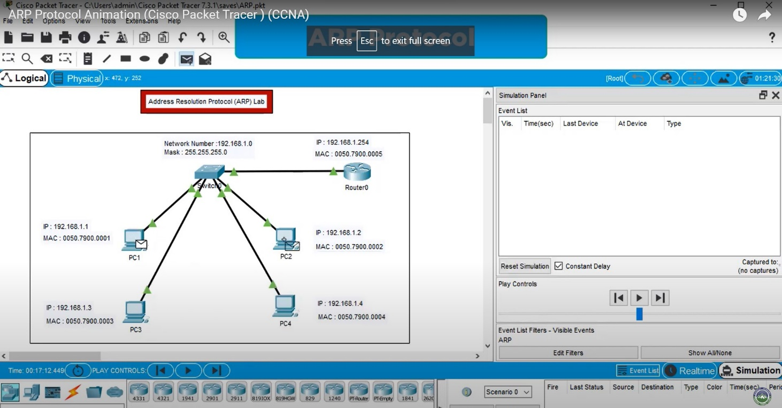

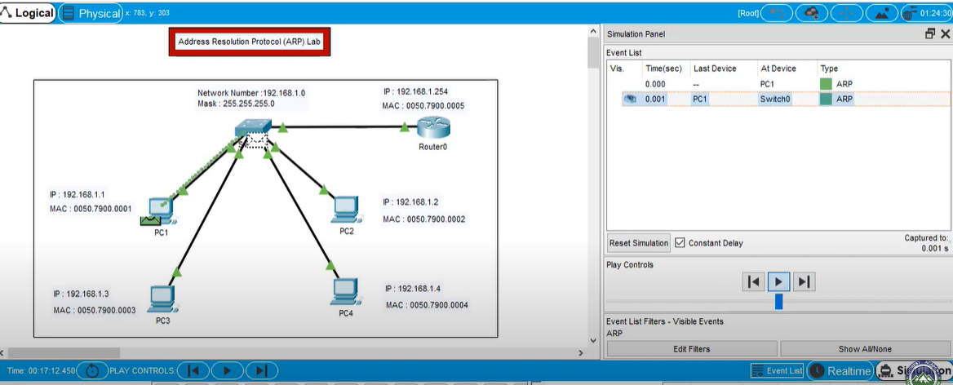

### Chapter3 Description

To simulate ARP (Address Resolution Protocol) and RARP (Reverse Address Resolution Protocol) using Cisco Packet Tracer, follow these steps:

* Create a network topology: Open Cisco Packet Tracer and create a network topology consisting of at least two devices, such as computers or routers, connected to a switch. Ensure that the devices are configured with IP addresses and subnet masks that are within the same network range.
* Configure ARP and RARP: Configure ARP and RARP on the devices by enabling the protocols and setting the appropriate parameters, such as the timeout values and cache sizes. This can be done through the device's command-line interface (CLI) or through a graphical user interface (GUI), depending on the device and protocol being used.
* Test ARP and RARP: To test ARP, initiate communication between two devices on the network by sending a ping request from one device to another. The ARP protocol should resolve the destination device's MAC address and add it to the ARP cache. To test RARP, initiate communication between a device and a server by requesting the server's MAC address using its IP address. The RARP protocol should resolve the server's MAC address and add it to the RARP cache.
* Monitor and troubleshoot: Monitor the ARP and RARP caches on the devices to ensure that they are functioning properly. If there are any issues, troubleshoot by checking the network configurations and protocol settings.
* In addition to ARP and RARP, there are many other networking protocols that are used in network communication. Here are a few examples:
* Transmission Control Protocol/Internet Protocol (TCP/IP): This is a suite of protocols used for communication over the internet and other networks. TCP is responsible for establishing and maintaining a reliable connection between devices, while IP is responsible for routing packets of data between devices.
* User Datagram Protocol (UDP): This is a protocol used for communication over the internet and other networks that does not require a reliable connection. UDP is faster than TCP, but it is also less reliable, as packets can be lost or delivered out of order.
* Hypertext Transfer Protocol (HTTP): This is a protocol used for communication between web browsers and web servers. HTTP is used to request and receive web pages and other content from servers.
* Simple Mail Transfer Protocol (SMTP): This is a protocol used for sending email messages between email clients and servers. SMTP is responsible for transferring messages between servers, while other protocols like POP3 and IMAP are used for retrieving messages from servers.
* Domain Name System (DNS): This is a protocol used for translating domain names (like [www.google.com](http://www.google.com/)) into IP addresses. DNS servers maintain a database of domain names and their corresponding IP addresses, and devices use DNS to look up the IP address of a domain name.
* These are just a few examples of the many networking protocols used in network communication. Each protocol has its own specific purpose and functionality, and they work together to enable devices to communicate with each other over networks. Understanding these protocols and how they work is essential for anyone working in networking or IT.

# In summary, ARP and RARP are important protocols for network communication, as they allow devices to communicate with each other on a local network by mapping IP addresses to physical or MAC addresses. ARP is used to resolve IP addresses to MAC addresses, while RARP is used to resolve MAC addresses to IP addresses.In summary, ARP and RARP are important protocols for network communication, as they allow devices to communicate with each other on a local network by mapping IP addresses to physical or MAC addresses. ARP is used to resolve IP addresses to MAC addresses, while RARP is used to resolve MAC addresses to IP addresses.

# Chapter 4

### SIMULATION/CIRCUIT DIAGRAM IN CISCO PACKATE TRACER

1. Sending Packet to Sender Client
2. Packet in System.
3. Packet Reaching Destination Client

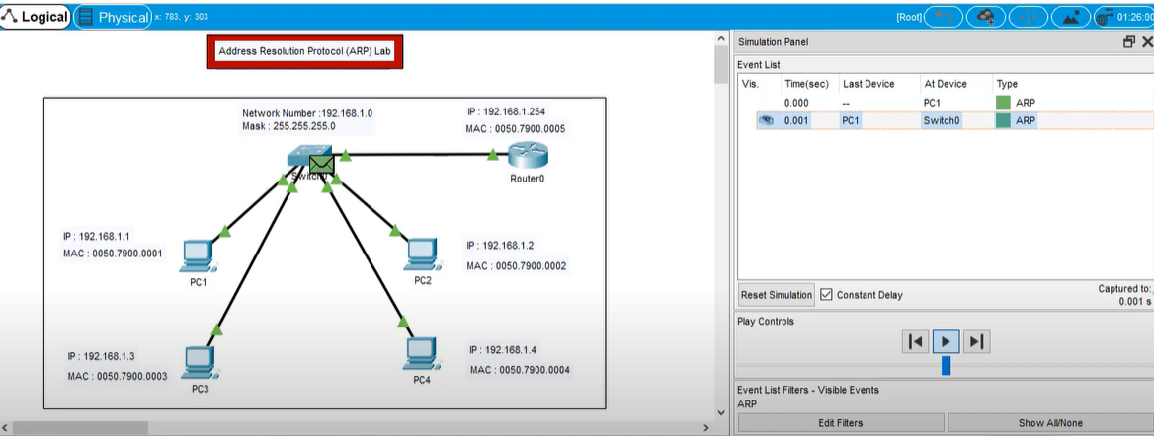

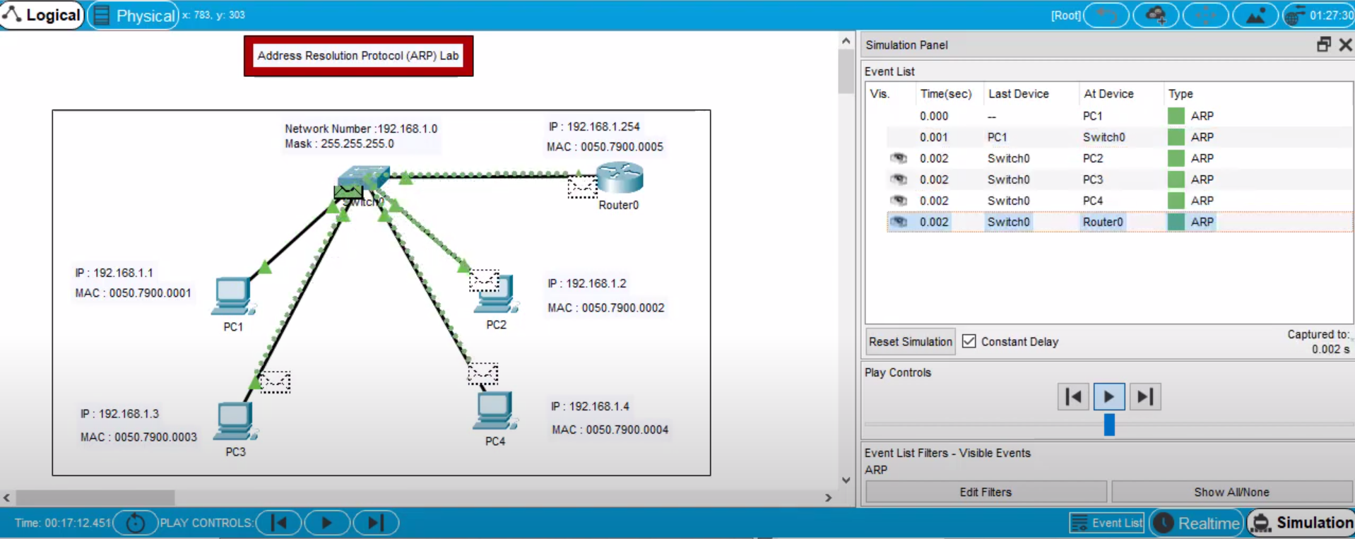

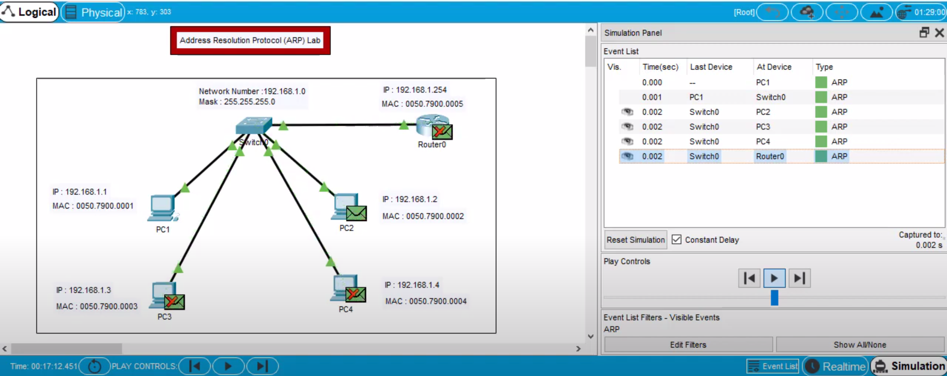

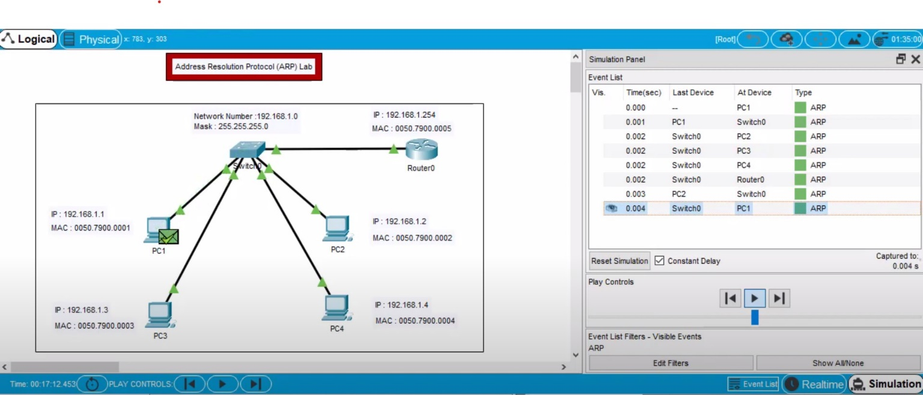

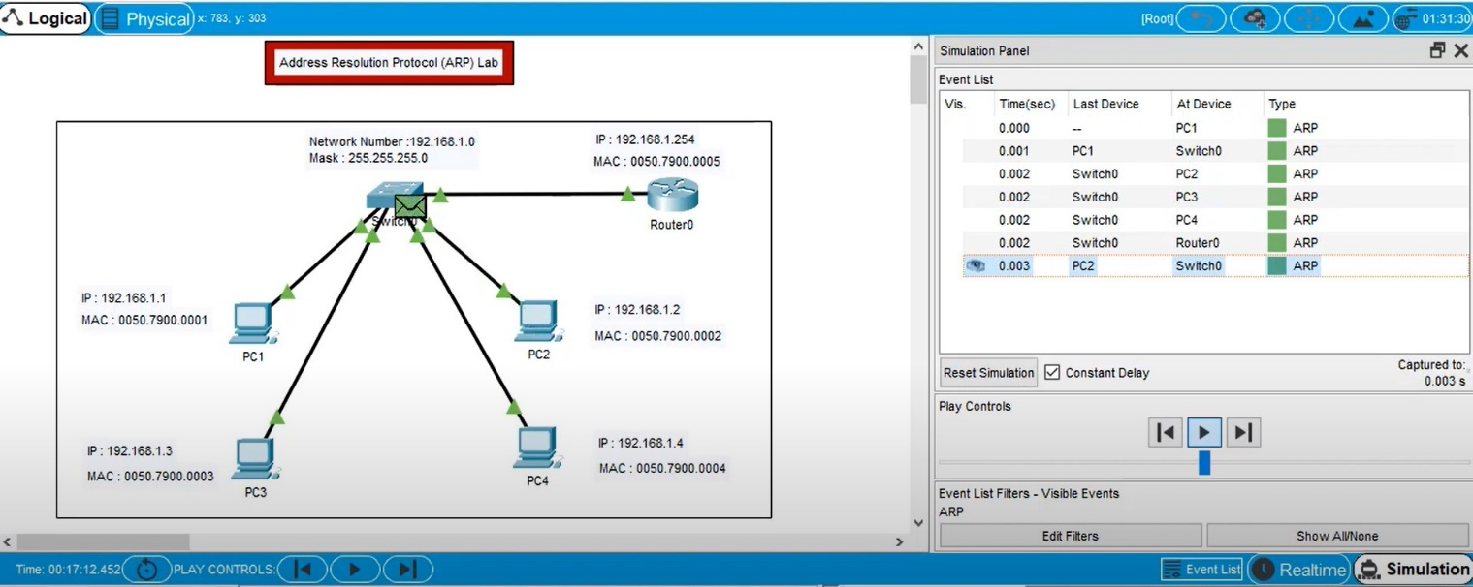

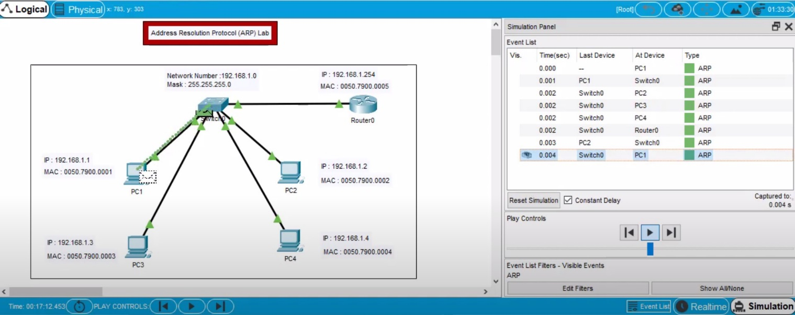

### References

To learn more about ARP, you can check out the following resources:

RFC 826: An official specification of the Address Resolution Protocol: <https://tools.ietf.org/html/rfc826>

ARP (Address Resolution Protocol) explained: <https://www.cloudflare.com/learning/network-layer/what-is-address-resolution-protocol-arp/>

ARP and its operations: <https://www.cisco.com/c/en/us/support/docs/ip/address-resolution-protocol-arp/118903-technote-arp-00.html>

To learn more about RARP, you can check out the following resources:

RFC 903: An official specification of the Reverse Address Resolution Protocol: <https://tools.ietf.org/html/rfc903>

RARP (Reverse Address Resolution Protocol) explained: <https://www.geeksforgeeks.org/reverse-address-resolution-protocol-rarp/>

ARP and RARP explained with examples: <https://www.geeksforgeeks.org/address-resolution-protocol-arp-and-reverse-address-resolution-protocol-rarp/>

### References

Youtube- https://[www.youtube.com/watch?v=2LkZ66zKTtU&ab](http://www.youtube.com/watch?v=2LkZ66zKTtU&ab)

Extra Hop- <https://www.extrahop.com/resources/protocols/icmp/>

Research Gate- [https://www.researchgate.net/publication/2449272_Internet_Control_Message_](https://www.researchgate.net/publication/2449272_Internet_Control_Message_Protocol) [Protocol](https://www.researchgate.net/publication/2449272_Internet_Control_Message_Protocol)

NPTEL-

[https://archive.nptel.ac.in/content/storage2/courses/downloads_new/106105160/](https://archive.nptel.ac.in/content/storage2/courses/downloads_new/106105160/noc) [noc](https://archive.nptel.ac.in/content/storage2/courses/downloads_new/106105160/noc)